Yield point tightening

Instruction about how to develop tightening parameters and how to follow up in running production for yield point tightened joints.

Background
Yield point tightening means that the screw is tightened so hard that it starts to yield (deforms plastically). This is not a problem, screws can take a lot of plastic deformation during tightening before it fractures. One to two extra thread revolutions is not unusual, so to take it same 20 degrees into the plastic zone is no problem.
So why do we do yield point tightening? The answer is that we will get a higher dynamic strength with the joint and in this way we can use a smaller screw compared to if we would have stayed with torque tightening.
One dis advantage is however that we need a more complicated assembly technology, torque plus angle control or torque plus gradient control instead of classical torque controlled tightening.
For clamp load critical high strength joints such as chassis joints and engine supports not to mentioned internal engine joints yield point tightening is however the preferred assembly technology.

Torque angle controlled yield point tightening
So how do we do it with a new joint? Well here comes some explanation:

- Start to use the values given in Assembly page. If the screw permanent elongation is smaller than given limits, increase the angle with 30 degrees. If it is too high decrease the control angle. Continue to tune until the permanent screw elongation is around 0.14mm.

- Now we will show how to measure the permanent screw elongation.

- To do this we need some special tooling. First we need to arrange with a micro meter measurement instrument. Either as a classical micro meter, see figure 1, or a micro meter clock attached to a fixture, see figure 2.
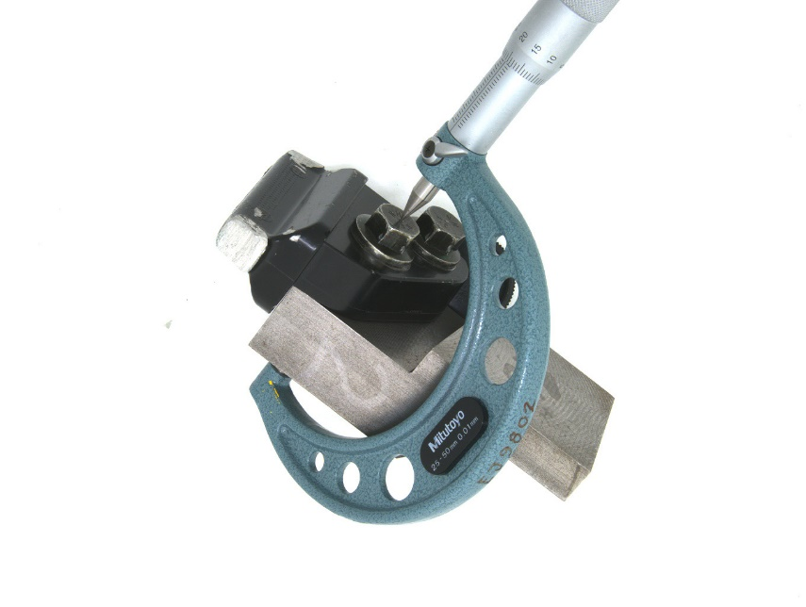
Figure 1. Classical micro meter to measure screw lengths in different situations. In this case with an assembled screw. With yield point tightening however the screw is measured before tightening and again after it has been loosened.

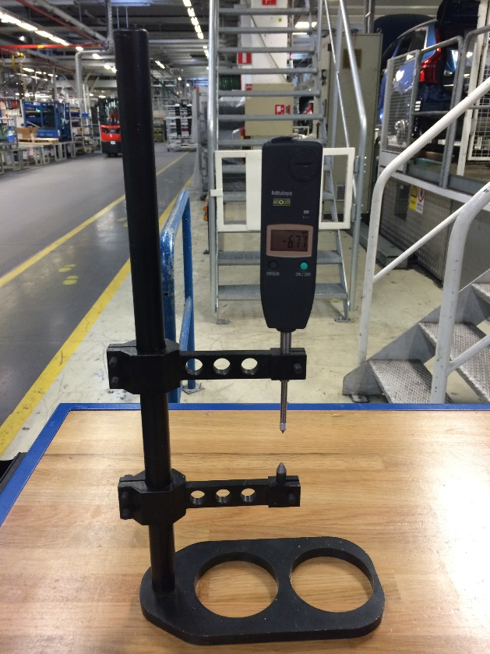
Figure 2. Fixture with micro meter clock to measure screw lengths before and after yield point tightening.
- Next is to arrange with a tool that can prepare the screw for measurement. It we choose the fixture shown in figure 4 we need to fabricate a fixture that can make conical indentation at both ends of the screw. See figure 5 for such a fixture. But it could also be good enough just to machine the screw end at the thread end in order to use a classical micro meter.

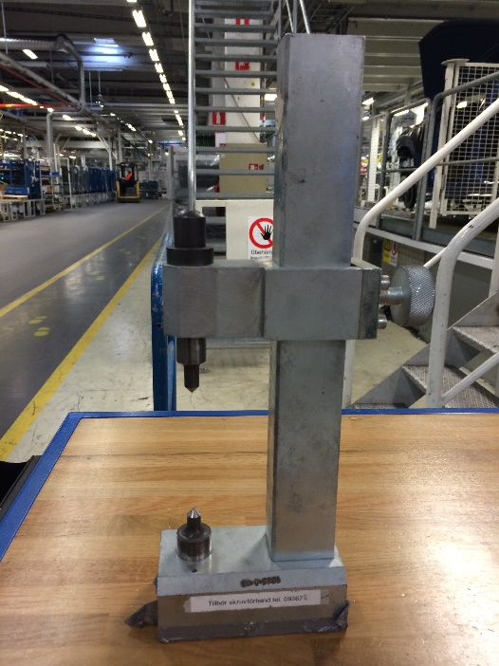Figure 3. Fixture to make conical indentation at both screw ends.

Procedure to measure permanent screw elongation with yield point tightened joints.
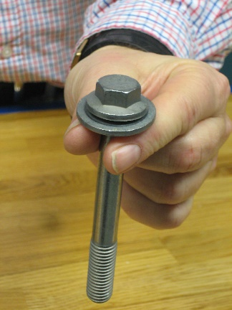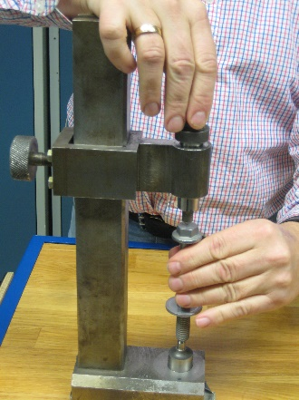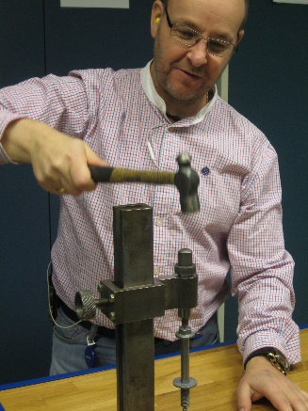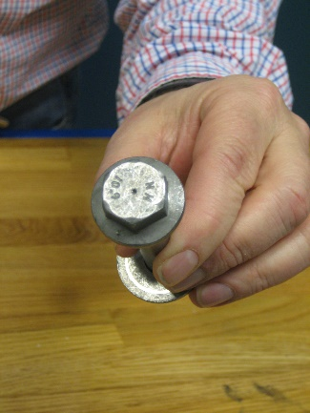
Take the screw and make indentation marks at both ends

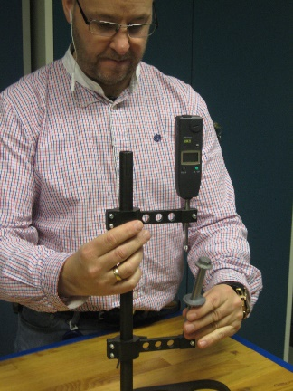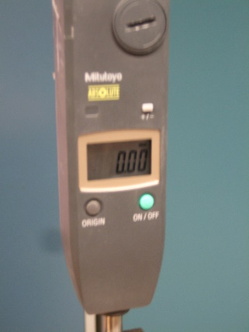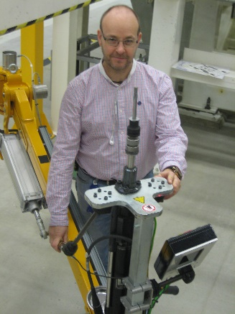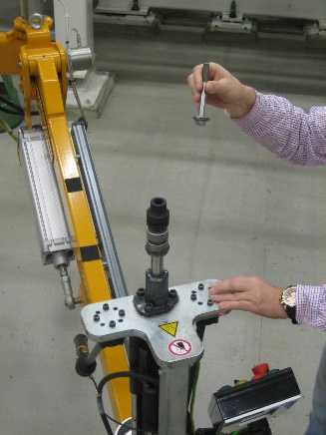
Put the screw in the measurement fixture and set the display to zero. Now take the screw to the product and tighten it to yield with suitable torque plus angle or torque plus gradient control. After assembly, loosen it and take it out for measurement.

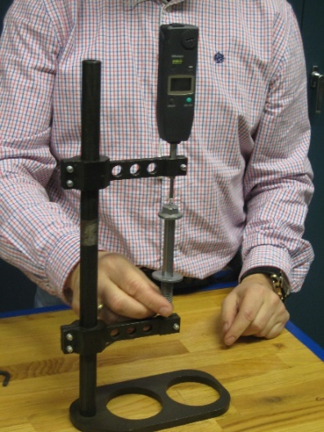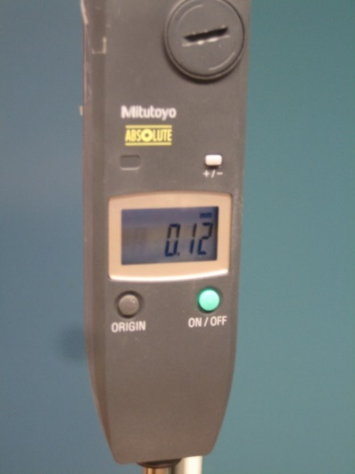
Measure it again in the same fixture and with the same fixture settings. The display will show the permanent screw elongation in this case 0.12mm which is well within the standard limits of 0.14 +/0.12mm.
- Assemble the screw with parameters given in the Assembly page

- Dismount the screw (loosen it) and measure the length again (see pictures above). The difference between the length before assembly and the one after disassembly is the permanent screw elongation.

- If necessary tune the control angle and tighten a new screw after its starting length has been measured. Do this with new screws until the permanent screw elongation is fulfilled. Write down the control angle value. This will later on be given in the PII.

- When this suitable control angle has been identified, make a number of tightening’s to see how the resulting end torque varies. Check that the resulting end torque is within given standard limits given in page Assembly. If not adjust the lubrication of the joint. The resulting end torque is reflecting the assembly friction and if they becomes too high the friction is too high and some other fastener lubrication or surface treatment may be needed.

- If a Gradient controlled yield point tightening is used the extra angle at the end of the tightening has to be tuned to fulfil the permanent screw elongation requirement. For the rest of the tightening parameters do as follows:

